Styling the ‘Useful Web Resources’ Page

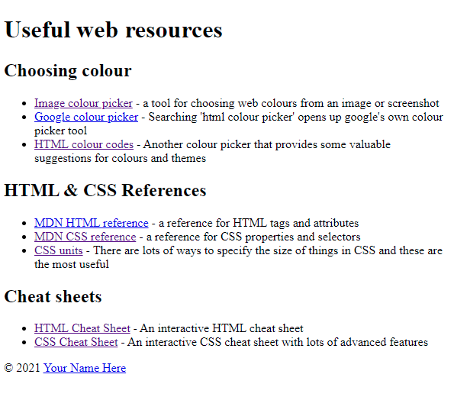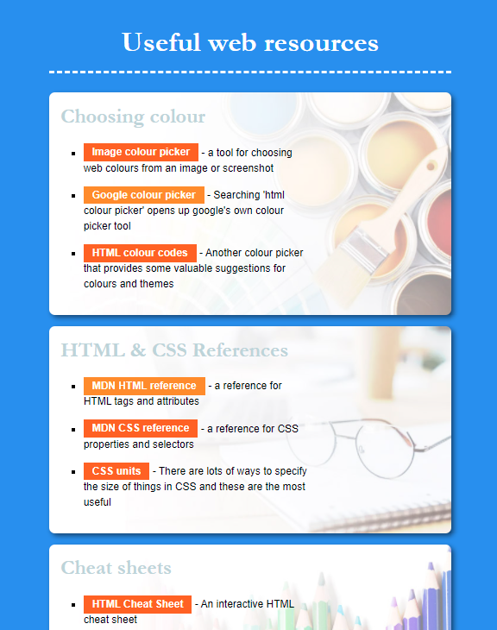

1. Analyze the HTML in your code editor – what elements are we working with?

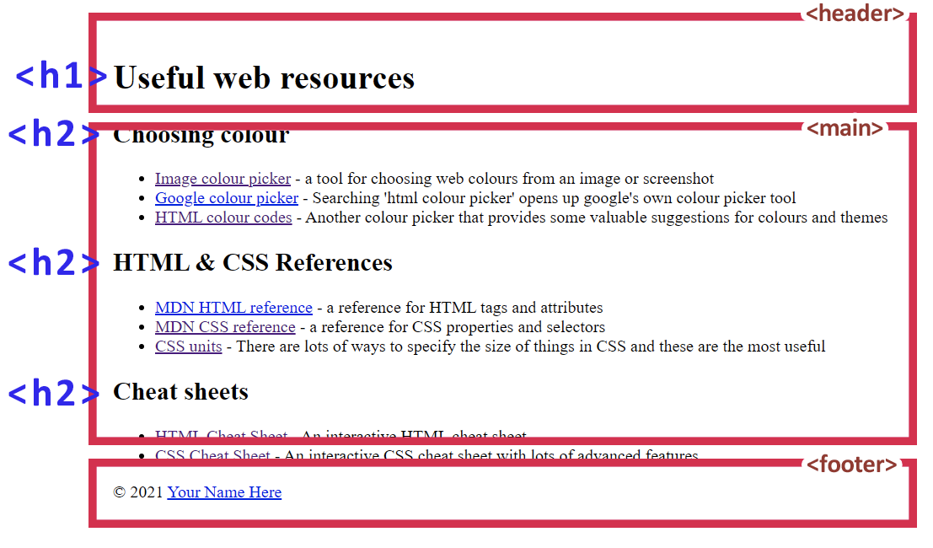

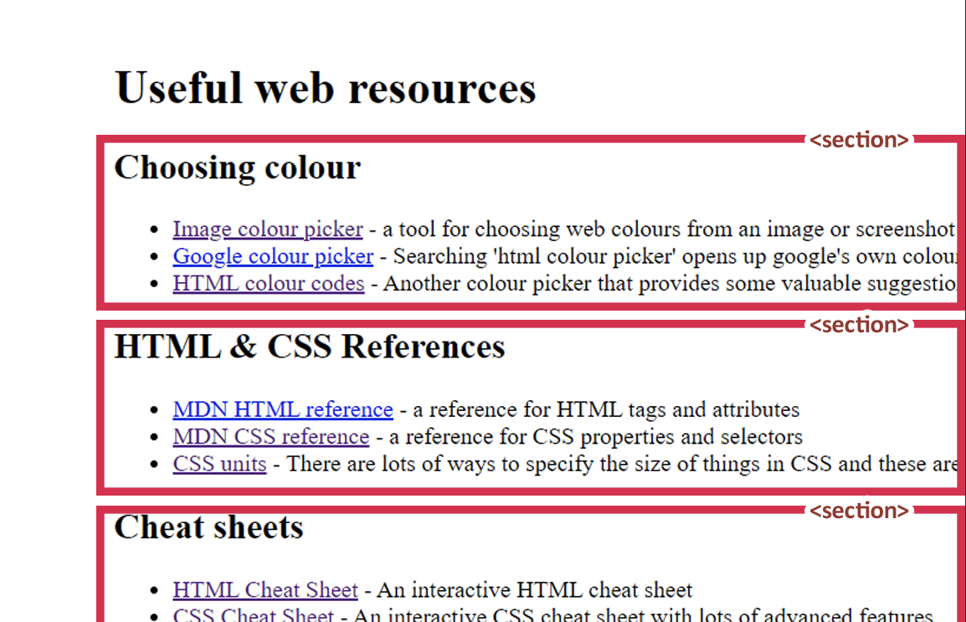

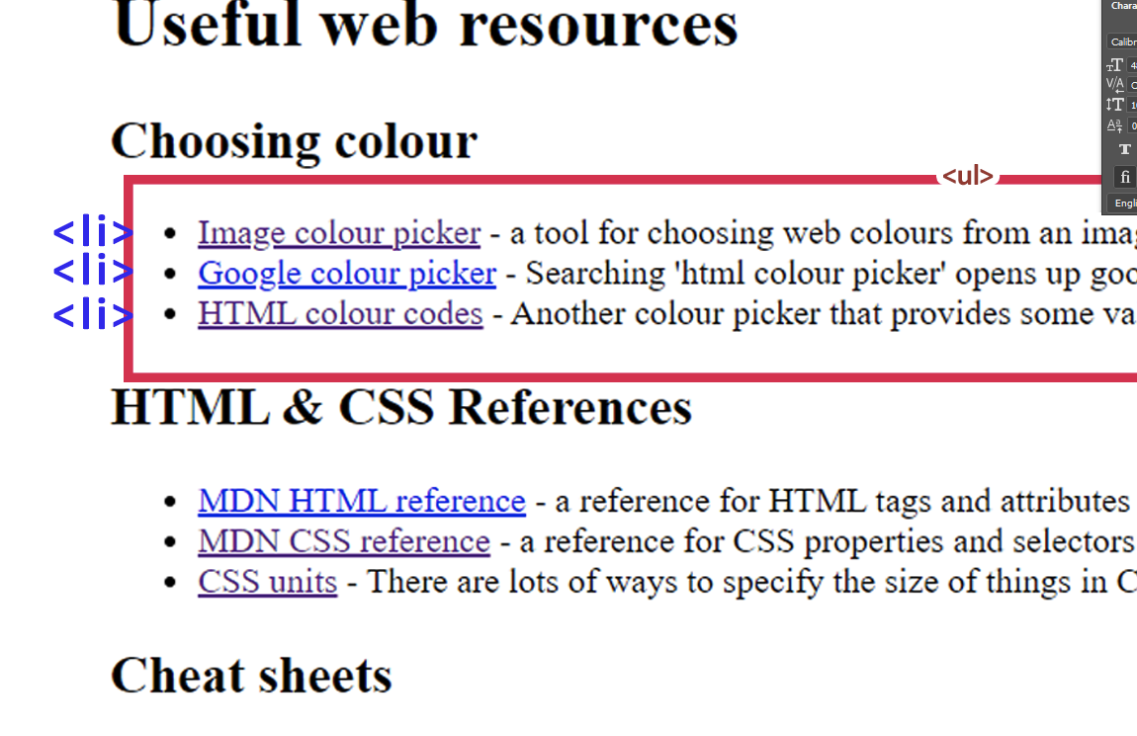

1. 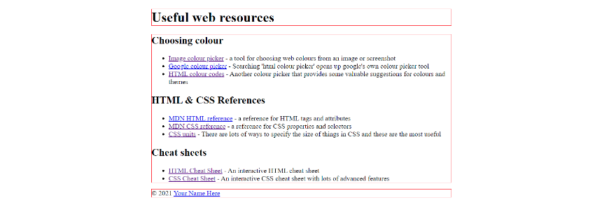 Open the **styles.css** file in your code editor and add the following code

main, header, footer {

    width: 700px;

    margin-left: auto;

    margin-right: auto;

    outline: 1px solid red;

}

Here we’re **selecting** the **main**, **header** and **footer** elements and giving them a width. By setting the **margins** to ‘auto’ they’re allowed to fill all the remaining width of the page, putting these boxes in the center.

Remove the ‘outline’ property to get rid of this preview.

1. Add the following CSS to change the font of the page and make the text a bit bigger.  
   By selecting the **body** tag, which contains everything on the page, the changes will apply to everything

body {

    font-family: sans-serif;

    font-size: 18px;

}

1. Apply the **background-color** property to this **body** selector to make the page a nice medium blue. Use the ‘google colour picker’ link to choose a colour for the value.  
   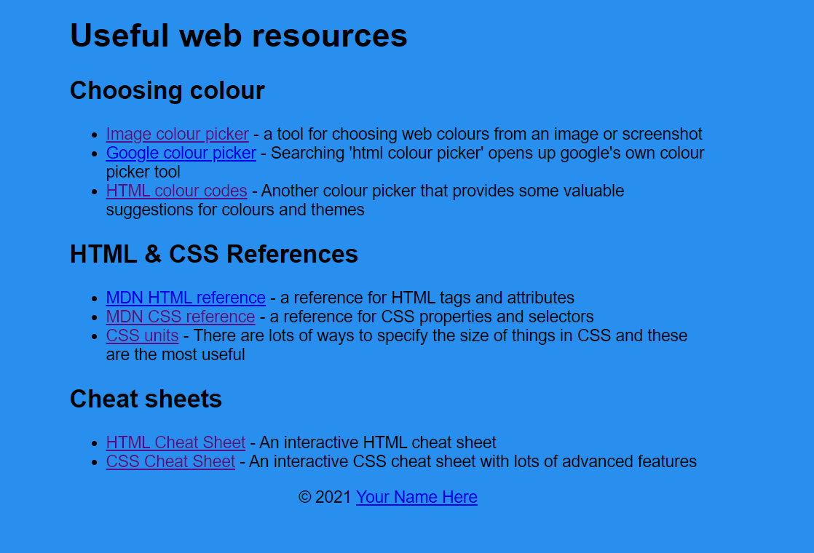
2. Add the following code to select the h1 element and style it  
   Replace the ??? with either the HTML keyword ‘white’ or by using the color picker

h1 {

    text-align: center;

    margin-top: 30px;

    color: ?????;

    font-size: 50px;

    font-family: Garamond, serif;

}

1. Use a google search to find out how to add a **5px** wide **dashed** **white** border to the above rule



Apply a padding of 20px to add more spacing between the header and the border.

1. Add the following code to style the section elements  
   Use a google search to find out how to apply **rounded corners** of 20px  
     
   Use the tool in the CSS cheat sheet link to apply a **shadow** to the section boxes  
     
   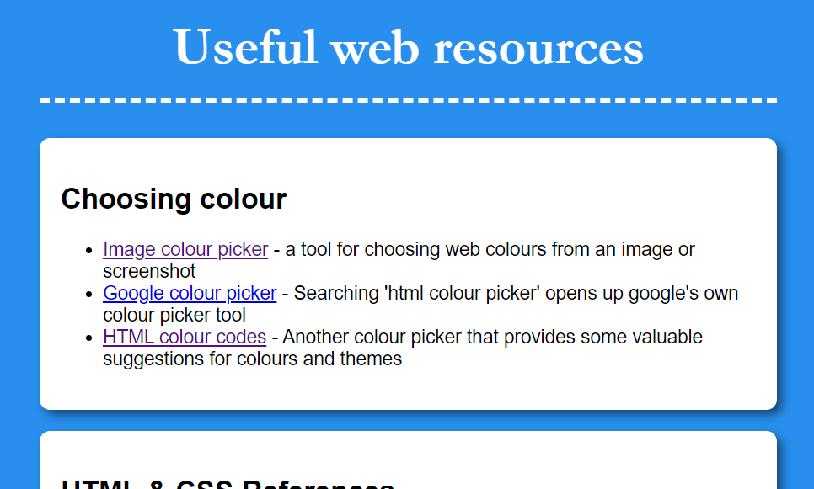

section {

    background-color: #ffffff;

    padding: 20px;

    margin-bottom: 20px;

}

1. Add the following code to style the links

main a {

    background-color: ????;

    padding: 5px 15px 5px 15px;

    text-decoration: none;

    color: white;

    font-weight: bold;

}

main a:visited {

    background-color: ?????;

}

main a:hover {

    background-color: ????;

}

The first rule **selects** all **<a>** elements inside a **<main>** element (this is so the footer <a> tag isn’t styled)  
  
The second selects all <a> tags that have been **visited**, while the third selects all a tags that are being **hovered** over with the mouse.

Use the colour picker tools to Replace the ???s with the following colors or your own and check the results

  

Add the following code to style the footer link separately. Can you create your own **visited** and **hover** styles for this footer link based on the above code?

footer a {

    color: #ffffff;

}

1. 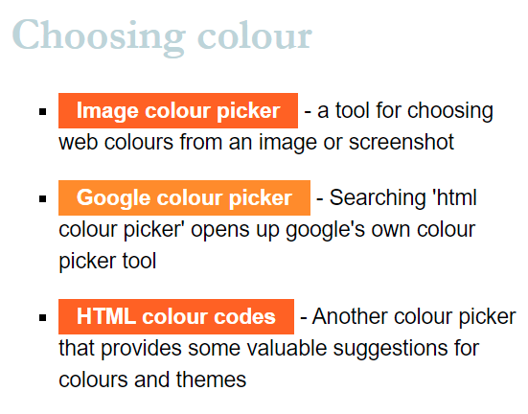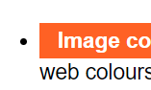Add the following code to style the lists and add more space  
     
     
   Google the css property for changing the **style** of the bullets to square to **replace the ?????????**   
   Setting the **width** as we did this makes the lists 60% the size of their parent and gives us some breathing room on the right side of the boxes. Try some different percentages to see the difference.

ul {

    ????????????

    width: 60%;

}

li {

    margin-bottom: 20px;

    line-height: 1.5em;

}

1. Add the following code to style the sub-headers

h2 {

    font-size: 2em;

    color: rgb(191, 212, 218);

    margin-top: 0;

    font-family: Garamond, serif;

}

The **font-family** property takes fonts in order of preference, in this case if **Garamond** isn’t found on the computer, it will revert to the best available **serif** font. Later we will learn how to use other, custom fonts.

The **em** unit of measurement for font size means *the size of the usual font* – in this case we’ve made the <h2> elements 2 times the size of the usual font. In the previous step we made the <li> element’s **line-height** (height of lines of text) 1.5x the size of the usual font.

1. In the next step we’ll add some background images to the individual blocks

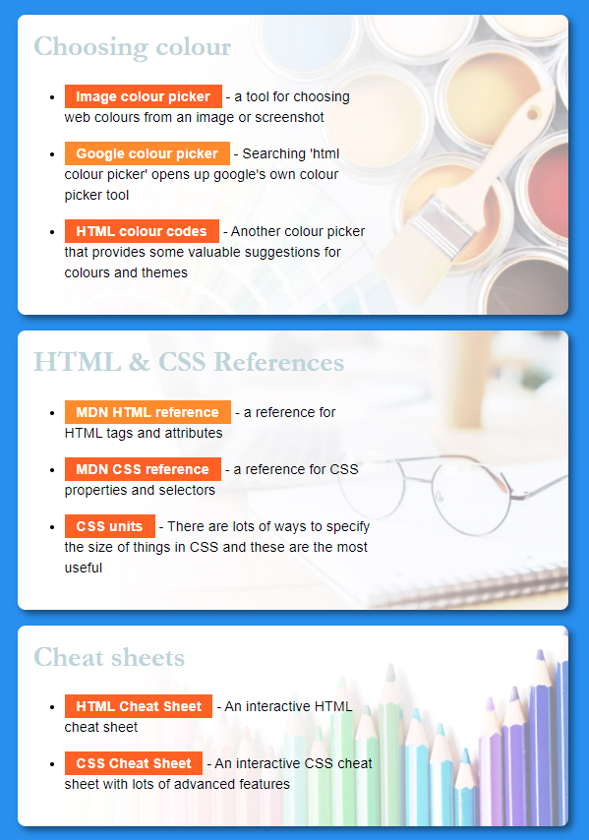

1. Add the following code – it won’t do anything just yet, but let’s examine what’s happening.

.colours {

    background-image: url('../images/paint.jpg');

    background-size: cover;

}

.references {

    background-image: url('../images/glasses.jpg');

    background-size: cover;

}

.cheatsheets {

    background-image: url('../images/pencils.jpg');

    background-size: cover;

}

The **url(“location”)** value will go look for a file to use.  
  
Because we’re in the **.css file** in the ‘css’ folder we need to go back a directory   
  
**../**  
  
then we enter the images folder  
  
**images/**  
  
then we choose our image

**pencils.jpg**

1. This code doesn’t do anything just yet. The **selectors** we’re using are targeting **classes –** in order for them to work, we need to have classes in our HTML file

Open the HTML file in your code editor and add the highlighted code to each of the 3 sections using the classes from our CSS in step 12.

   <section class="colours">

        <h2>Choosing colour</h2>

            <ul>

                <li>

                    <a href="https://imagecolorpicker.com/">Image colour picker</a> - a tool for choosing web colours from an image or screenshot

                </li>

                <li>

                    <a href="https://www.google.com/search?q=html+colour+picker">Google colour picker</a> - Searching 'html colour picker' opens up google's own colour picker tool

                </li>

                <li>

                    <a href="https://htmlcolorcodes.com/">HTML colour codes</a> - Another colour picker that provides some valuable suggestions for colours and themes

                </li>

            </ul>

        </section>

1. Compare your results for the page to the below image.

